I sent an update a month or so ago about our re-branding. I would like to be sure that all of your team is aware to make sure the theme and branding is updated on all of our studies.

PackFlash should be ok, because the template creates it updated -  but if you are copying an old study or using your own template for a Transaction Path, Unpacked, ShopperLab, In person etc...please make sure everything is updated.  Please pass this to the programmers.

1. Change the "theme" to "Behaviorally New Jan 2025"

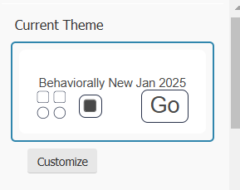

1. Update Logo line of code to:  ss:logoFile="selfserve/1da7/191272/Behaviorally_HeaderLogo.jpg"
2. Change font from Hind to arial here:  font-family: 'Hind';  font-family: 'arial';
3. Upload attached image and update "IntroPage.jpg" logo to "IntroPage2025.jpg" in 2 places:

      $ (".survey-page").css("background", "url('[rel IntroPage.jpg]') no-repeat center center fixed");

      $ (".survey-page").css("background", "url('[rel IntroPage2025.jpg]') no-repeat center center fixed");

Those are all the updates needed. Thank you!

Michele